User Guide

Main interface: Dashboard

* UI to navigate subsets in all universes with feature of adding subset, counter or dimension.

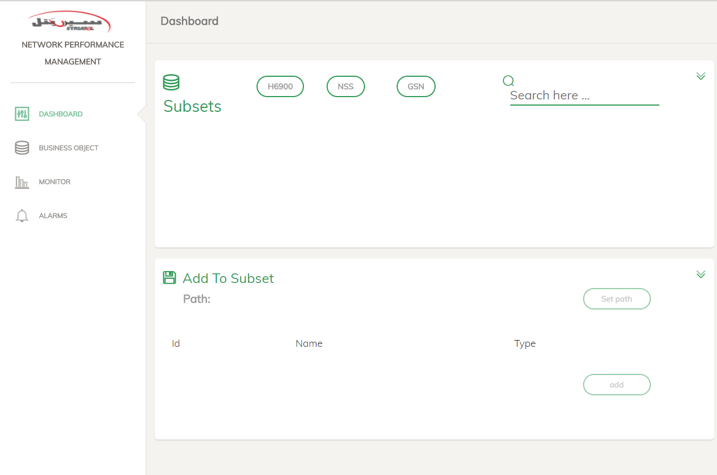

To add:

* 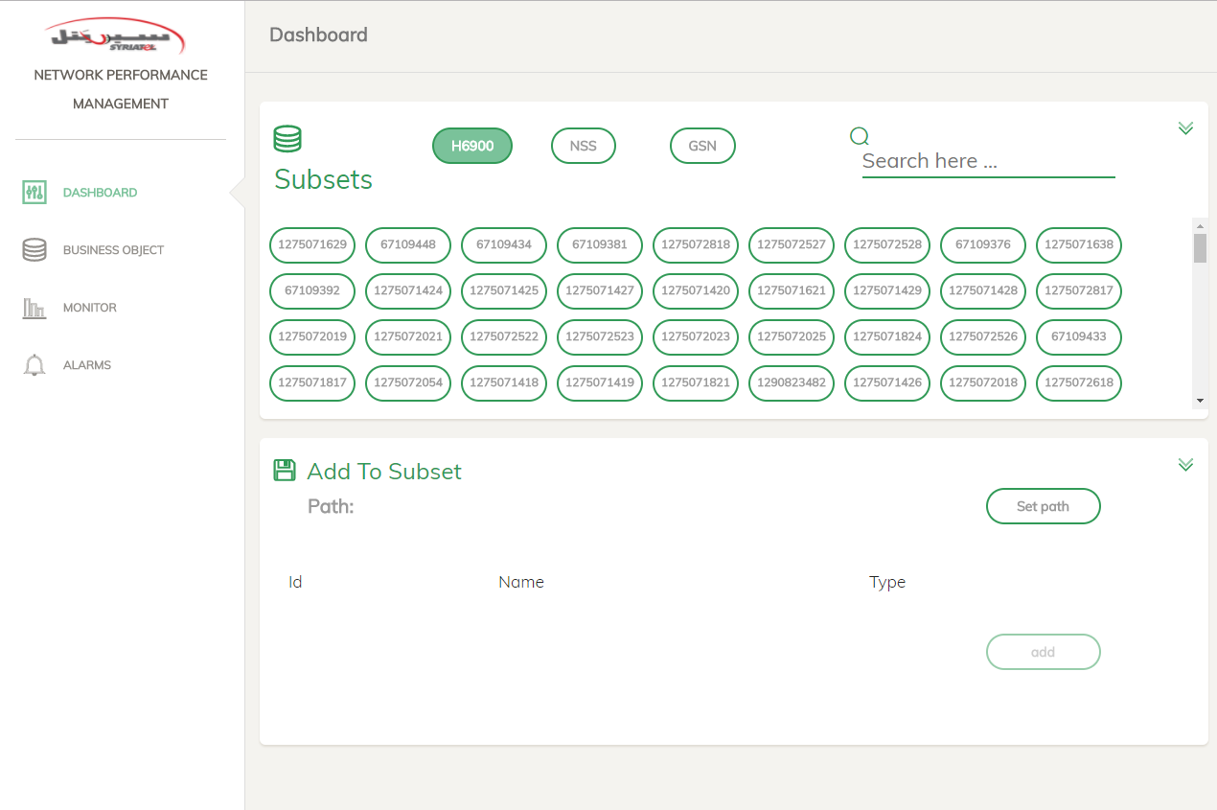Click on universe name you want to add in (lets take H6900 for example).
* Subsets in universe will be shown, you can search the subset you want by typing its Id or part of it.
* By clicking on any subset, some details of it will be shown.

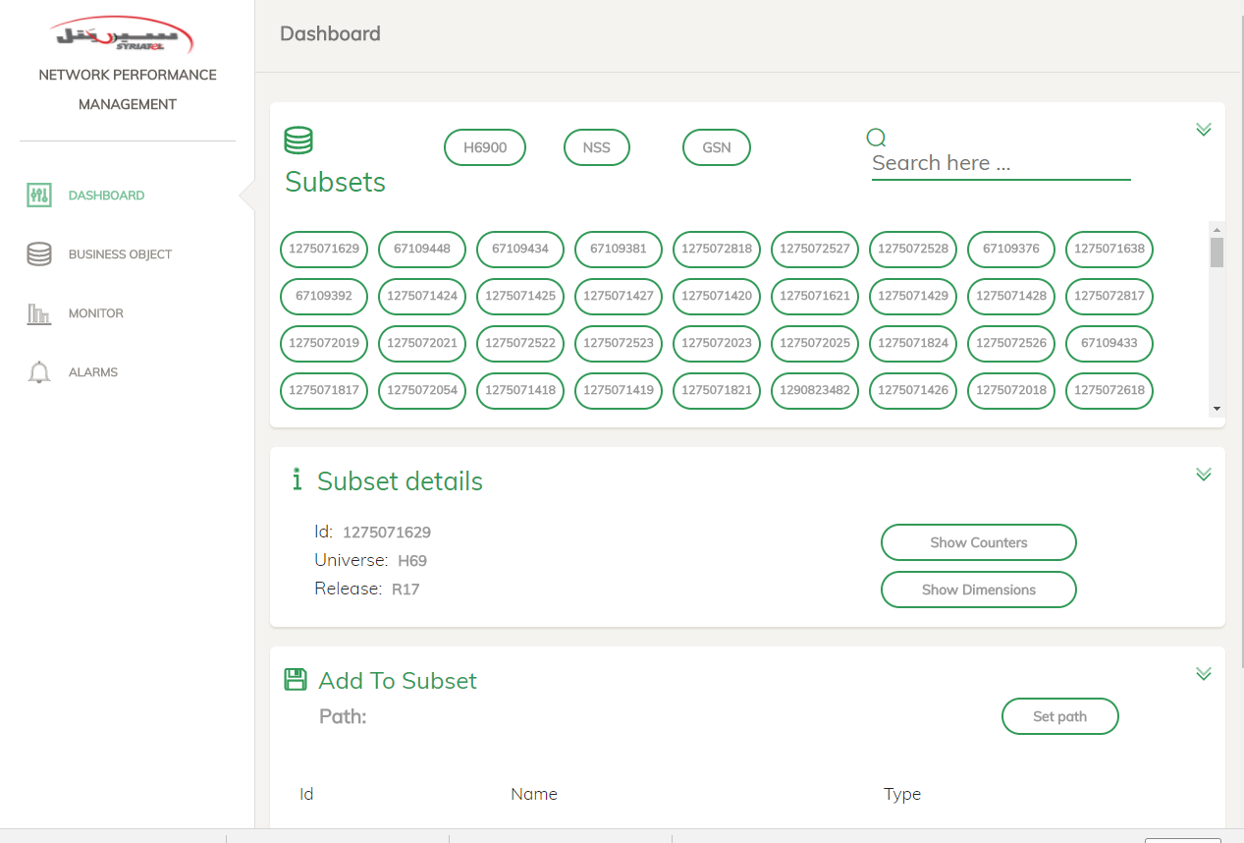

* And two buttons will appear, Show Counters to get counters of selected subset, and Show Dimensions to get dimensions of it.

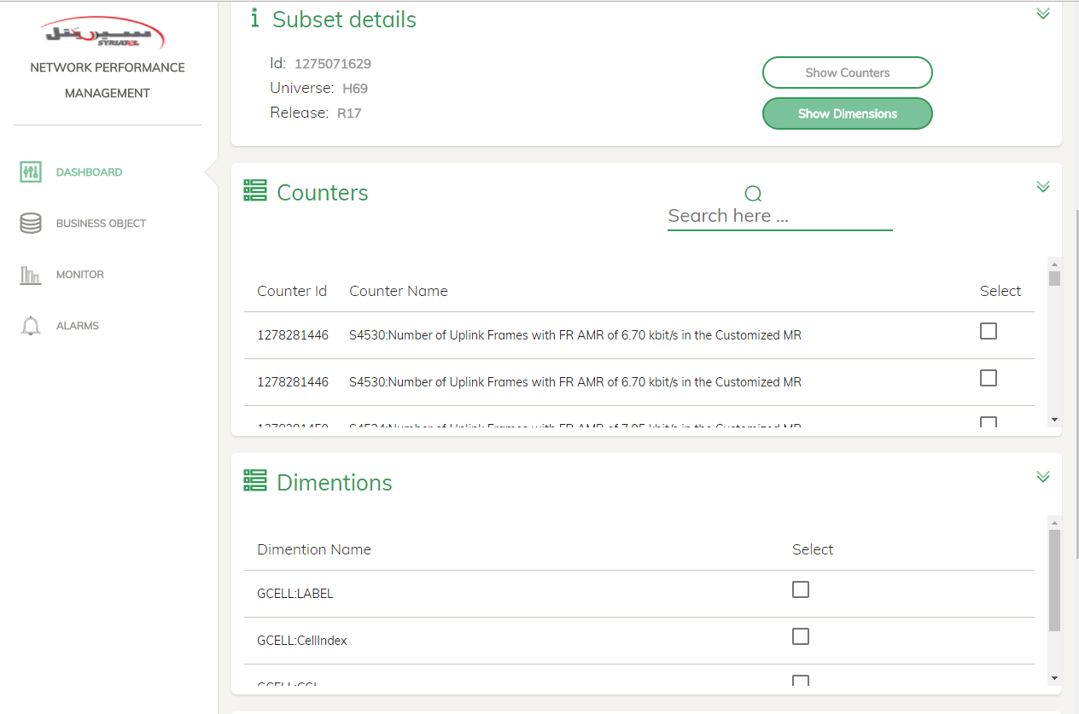

* Here you can check beside counters and dimensions to select which of them you want to add.

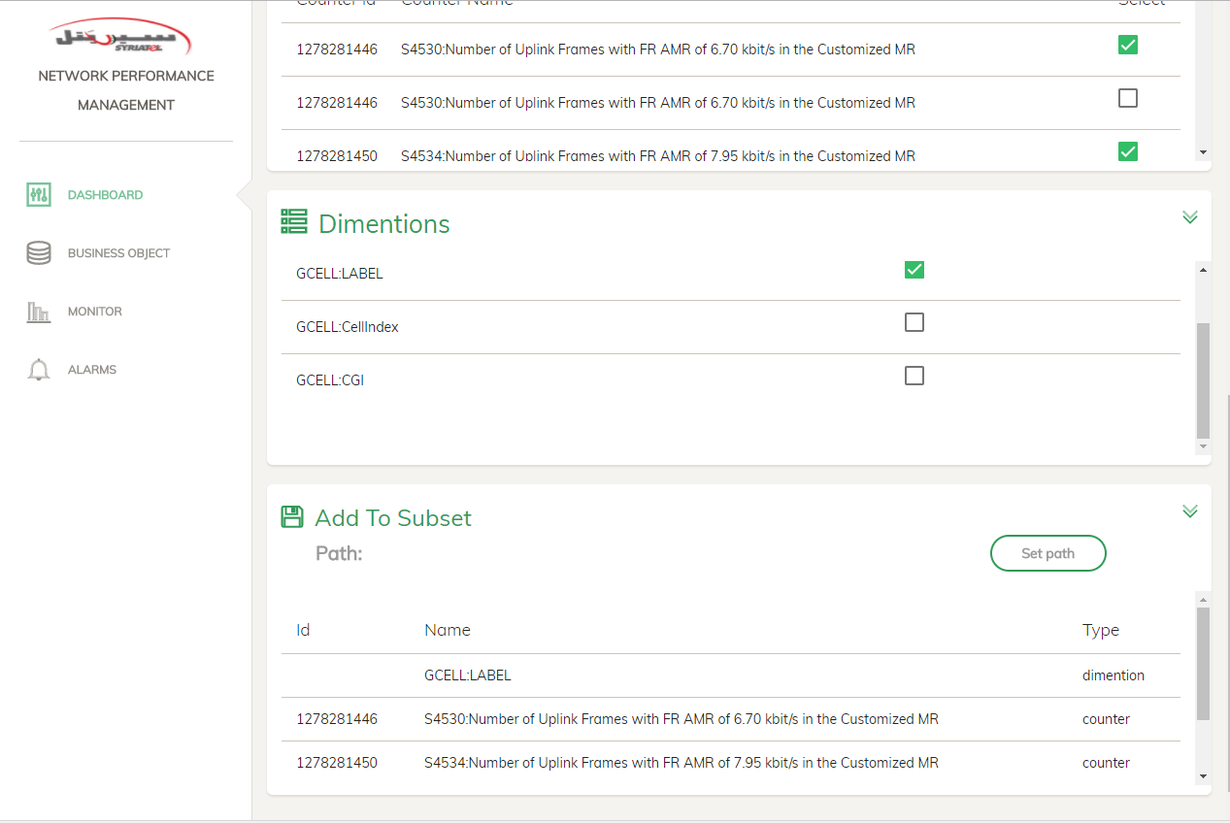

* Here you can note selected dimension (GCELL:LABEL) and two counters to be added.
* Now, you can click on Set Path button, it will take you to Business Object page to specify the path you want to add in.

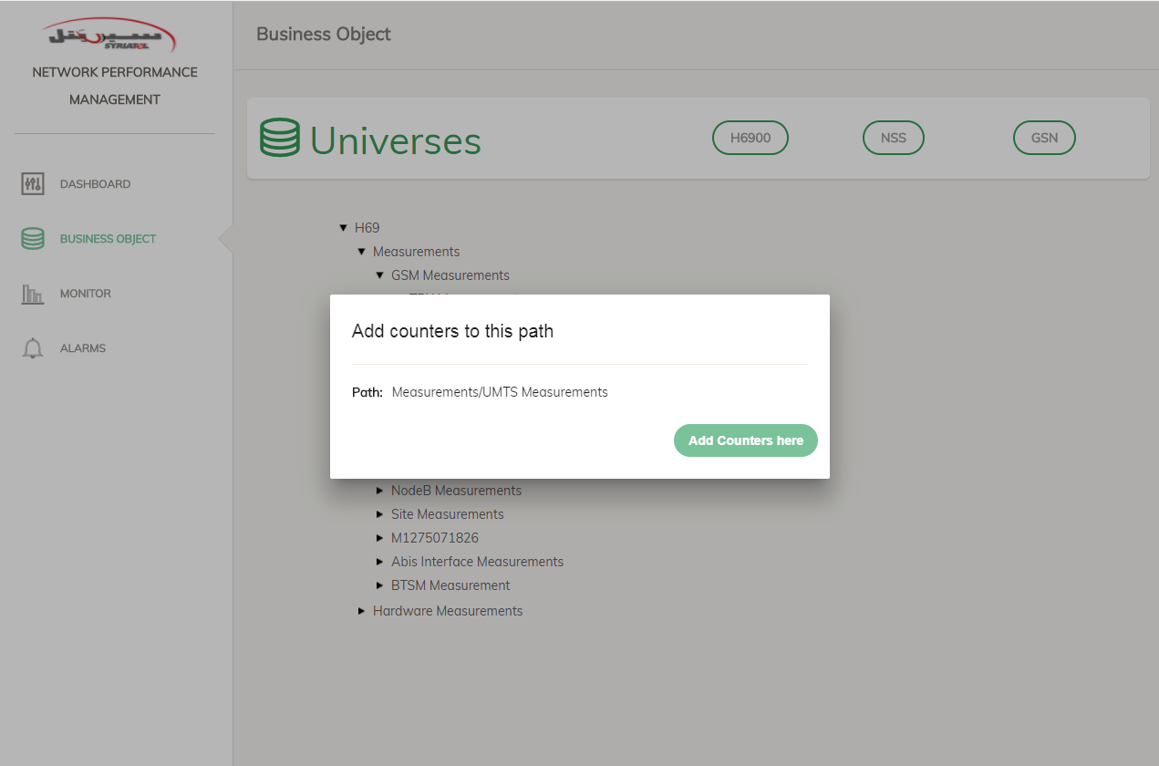

* Universe tree is shown, you can navigate it and click on any folder to show this pop up.
* Now click on Add Counters Here to go back to Dashboard page with the path.

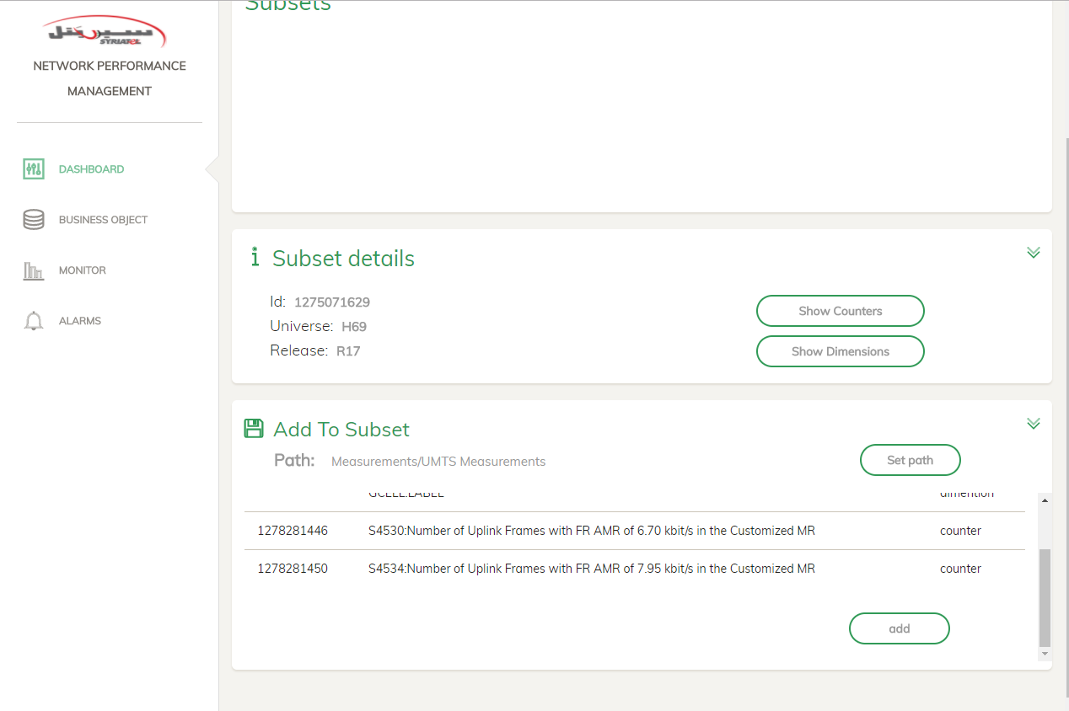

* You note that add button is enabled now, click it to add the selected items.

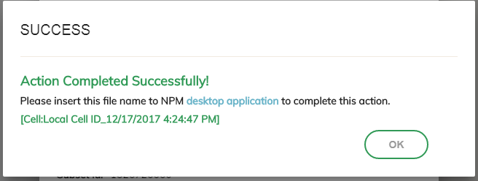

* [Cell:Local Cell ID_12/17/2017 4:24:47 PM] is the process code that you have to insert to desktop application to complete the action.

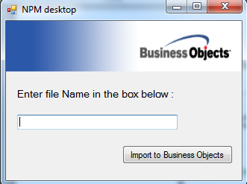

* Business Object:

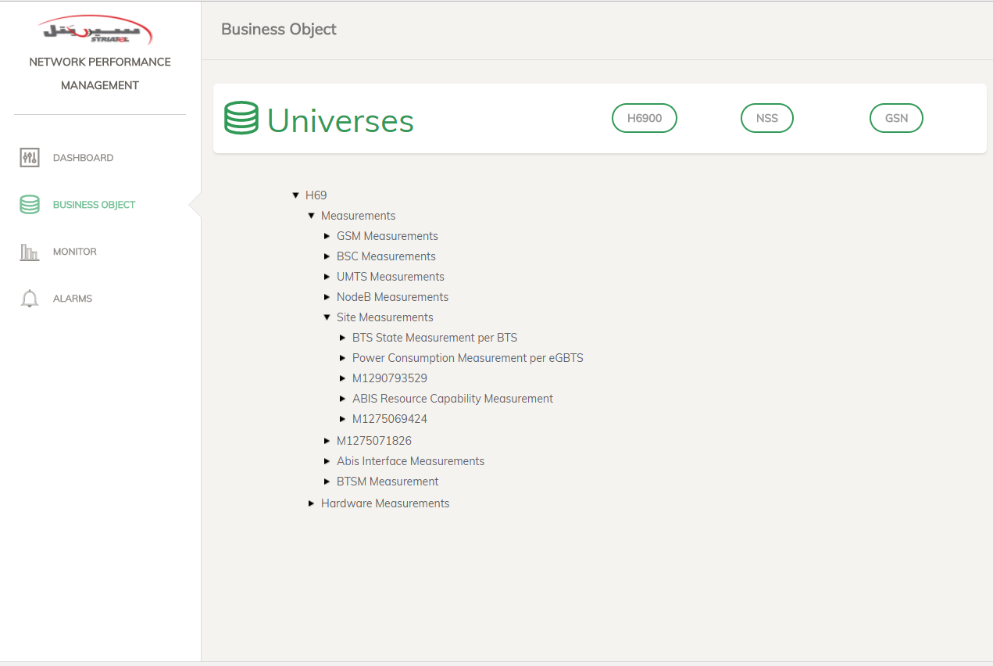

Page to view universes’ tree as it is in Business Object app, click on universe name to get the tree, and then you can click on folder name to show pop on to select this folder to add items here ( as mentioned in dashboard page).

Also, you can click on counters (leafs in tree) to get some details about selected counter as below :

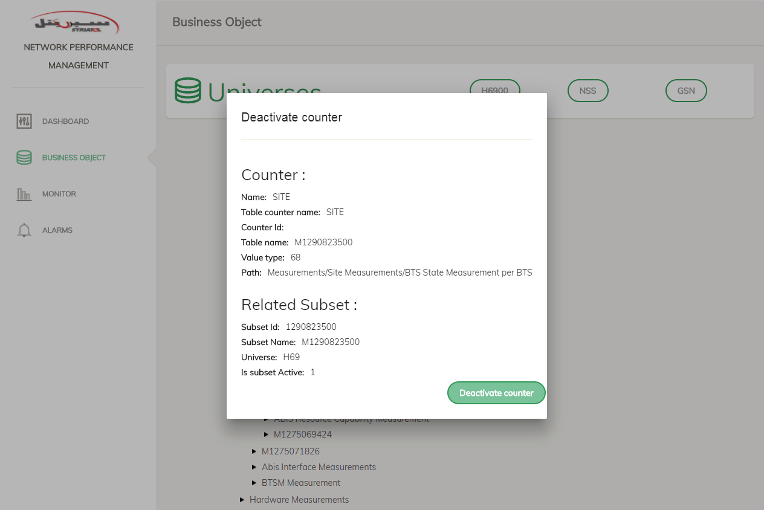

Notice here Deactivate counter button, you can deactivate counter by clicking on it to hide counter from Business Object.

**--(ADMINS AMU)**

* Monitor:

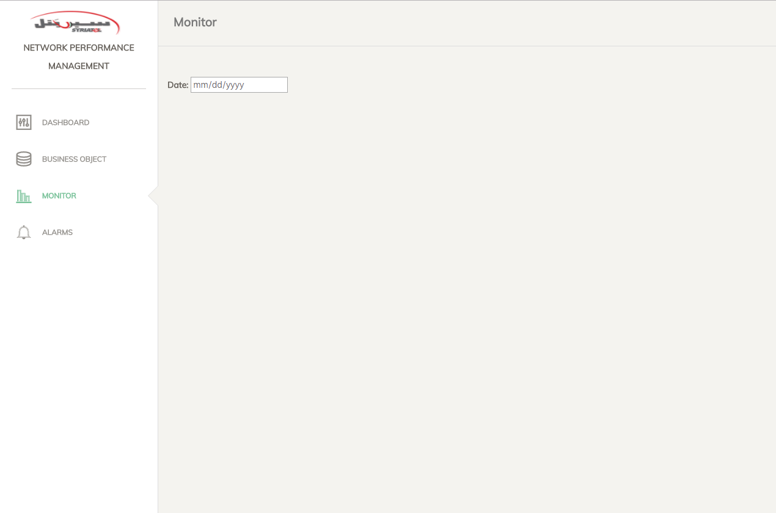

Page to monitor loading process, peaks, KPIs and accumulations in Counters DB.

* By selecting the date, universes’ names will be appeared, you can click on any one to get its item.
* In H6900, loading chart, peak, KPI, and daily accumulations will be shown.
* In peak, KPI, and daily accumulations, subset with red background has an alarm which refers to some missing, you can click to any to view some details.
* 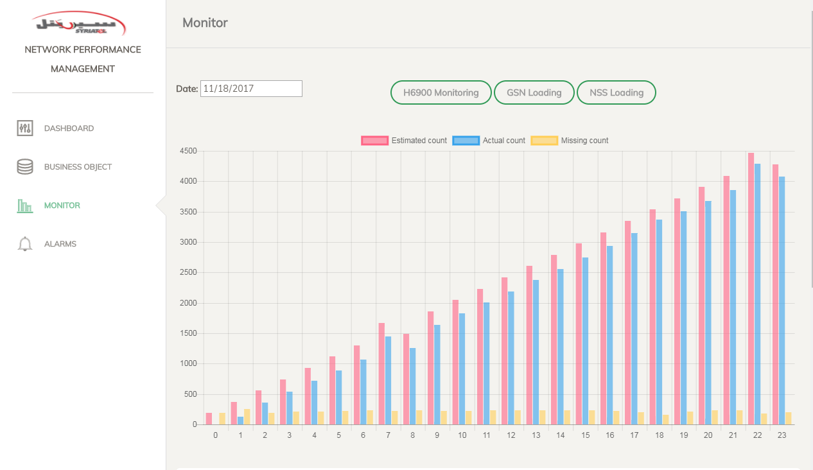In chart, you have to click on the colors above to determine which bars you want to display.

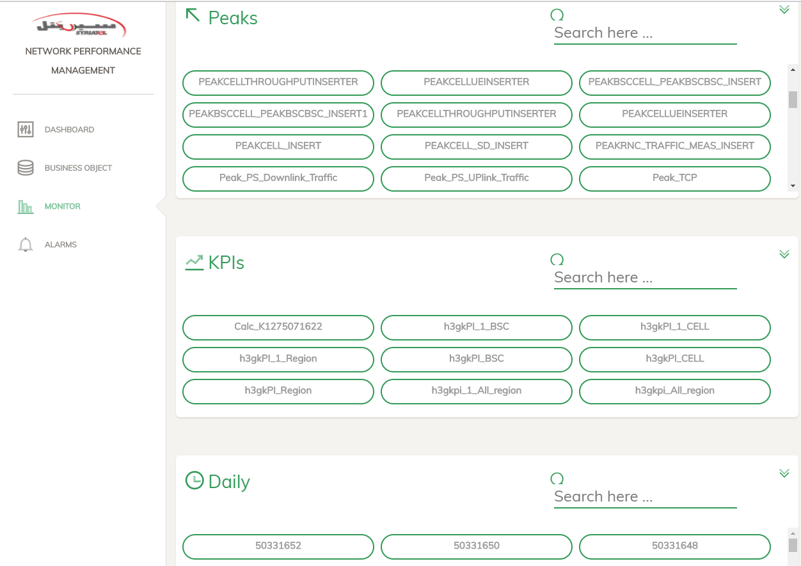

* Alarms: **(ADMINS AMU)**

Page to view alarms related to missing issues with some details for each alarm.

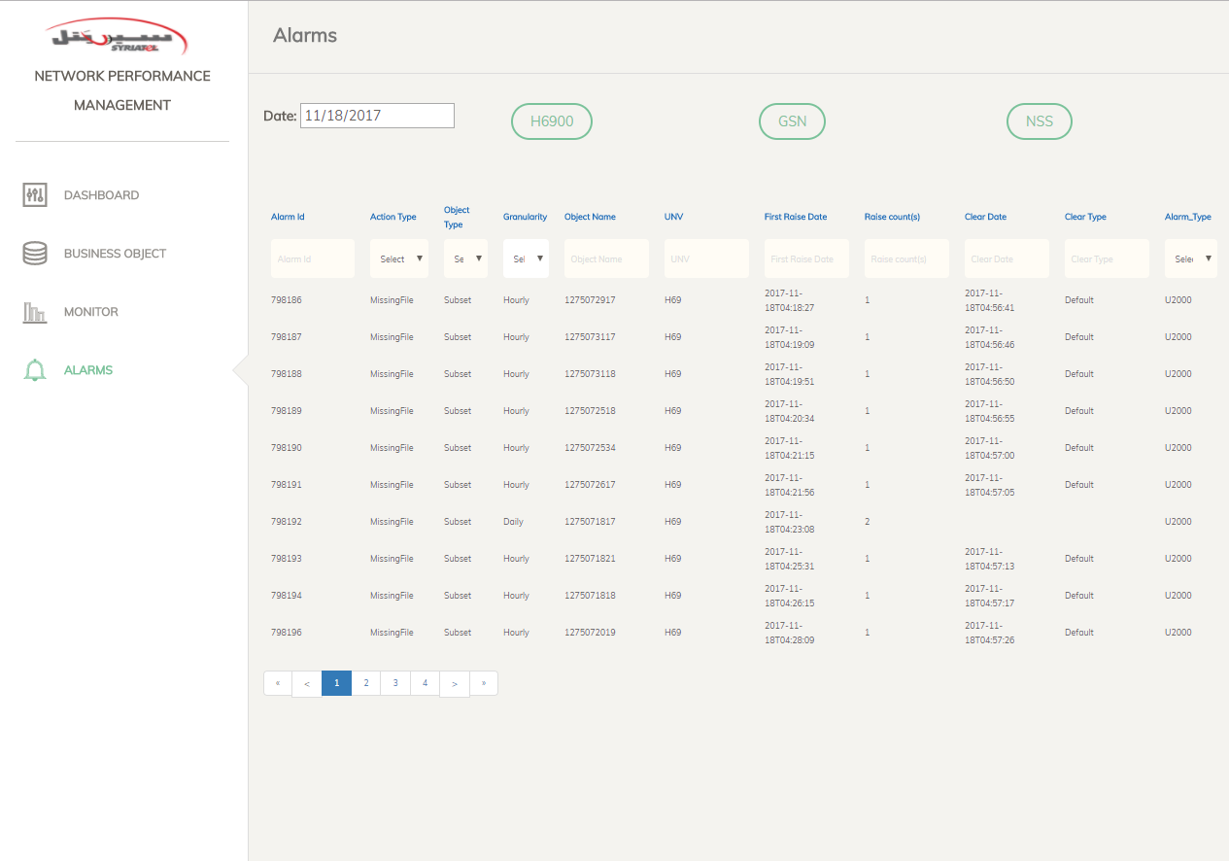You can filter in the columns in two way, list and type to search.

For example: in Action Type you can filter by choosing MissingFile or MissingData from the list.

In UNV you can filter by type the universe name in the top text box.

